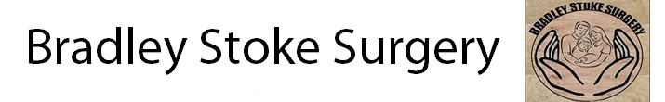

PATIENT REFERENCE GROUP

FEEDBACK REPORT

MARCH 2015

Annex D: Standard Reporting Template

[Name] Area Team
2014/15 Patient Participation Enhanced Service – Reporting Template

Practice Name: Bradley Stoke Surgery

Practice Code: L81649

Signed on behalf of practice: Dr Faisal Siddiqui Date: 29/3/15

Signed on behalf of PPG: Mr Ashish Mehta Date: 29/3/15

- Prerequisite of Enhanced Service – Develop/Maintain a Patient Participation Group (PPG)

Does the Practice have a PPG? YES

Method of engagement with PPG: Face to face, Email, Other (please specify)

The practice currently has a participation group from previous years. Unfortunately this is not representative of current patient population and is heavily skewed towards the older age groups and white British ethnic group.

In previous years for recruitment we have:

- Displayed posters in the Practice advertising and encouraging patients to join
- Paper copies of registration forms displayed in the Practice.
- Added information and a registration link on the Practice website
- Added an invitation slips for clinical staff to give at consultation and clipped to repeat prescription.

This year we employed additional methods to help recruit patient hoping to capture our young age groups. In particular we focused on creating a virtual group. We utilised the practice website and created an online Google form for an online survey.

To ensure our PRG was manageable and focused we aimed for a group of 40 patients matching the various demographics of the patient population. We achieved 39 patients. This was almost treble in size of our previous PPG group of 12.

At the time of PPG creation we have a total practice population of 15, 700.

Number of members of PPG: 39

Detail the gender mix of practice population and PPG:  (%) Male Female  Practice 7896 (50.2%) 7877 (50.1%)  PRG 19 (48.7%0 20 (51.2%) | Detail of age mix of practice population and PPG:  (%) <16 17-24 25-34 35-44 45-54 55-64 65-74 > 75  Practice 2975 (18.9%) 688 (4%) 1919 (12.2%) 1936 (12.3%) 1435 (9.1%) 643 (4%) 396 (2.5%) 241 (1.5%)  PRG 0 4 (10.2%) 8 (20.5%) 11 (28.2%) 8 (20.5%) 4 (10.2%) 3 (7.6%) 1 (2.5%)
Detail the ethnic background of your practice population and PRG:

 | White |  |  |  | Mixed/ multiple ethnic groups
% | British | Irish | Gypsy or Irish traveller | Other white | White &black Caribbean | White &black African | White &Asian | Other mixed
Practice | 10023  (63.8%) | 64  (0.4%) | 0 | 2270  (14.4%) | 8  (0.05%) | 15  (0.095%) | 20  (0.12%) | 112  (0.7%)
PRG | 25  (64%) | 0 | 0 | 6  (15%) | 0 | 0 | 0 | 0

 | Asian/Asian British |  |  |  |  | Black/African/Caribbean/Black British |  |  | Other
% | Indian | Pakistani | Bangladeshi | Chinese | Other  Asian | African | Caribbean | Other Black | Arab | Any other
Practice | 1759  (11.2%) | 221  (1%) | 27  (0.1%) | 298  (1.9%) | 330  (2.1%) | 323  (2%) | 117  (0.7%) | 38  (0.2%) | 76  (0.4%) | 0
PRG | 4 (10%) | 1 (2.5%) | 0 | 1 (2.5%) | 1 (2.5%) | 1 (2.5%) | 0 | 0 | 0 | 0

Describe steps taken to ensure that the PPG is representative of the practice population in terms of gender, age and ethnic background and other members of the practice population:

We managed to get our patient population represented by actively targeting our under represented groups. This was accomplished by creating EMIS searches for each individual group and approaching directly (either in person or via telephone) to patients to join the group. They were then invited to complete our survey.

It should be noted that due to consent and confidentiality issues patient under the age of 16 years old were not represented. To compensate for this we instead ensured that pregnant mothers were included as well as families and parents with young children. We felt doing this that the <16 years group would be able to air any views by responsible adult if needed. Pregnant mothers made up 2.5% of our PRG.

Other than pregnant mothers we also targeted carers as a group to include. This allowed us to give carers a voice for themselves as well the vulnerable dependents. They made up 2.5% of our PRG.

Are there any specific characteristics of your practice population which means that other groups should be included in the PPG?
e.g. a large student population, significant number of jobseekers, large numbers of nursing homes, or a LGBT community? Yes

If you have answered yes, please outline measures taken to include those specific groups and whether those measures were successful:

Yes, our population is skewed to a younger population. Please refer to section above on recruitment with emphasis on families and pregnant ladies.

- Review of patient feedback

Outline the sources of feedback that were reviewed during the year:

We identified the areas for priority from themes from complaints and from comments/feedback received from individual patients. Many suggestions were from our anonymous comments box at reception. Some had come from direct comments made to staff members at the practice in the form of a complaint or comment on the practice. Using the major themes we created an online survey.

The Practice initially conducted an online “in house” developed survey of our PRG members which ran from the 1st October 2014 to 3rd March 2015. Hard copies of this survey was also handed out in reception, so it was accessible to all patients without those with internet access. Patients were also invited to phone to give their results over the telephone to a dedicated reception member.

The survey was open to all members of our PRG and they were invited to complete the survey either online (by following the link in the email sent to them) or for patients without access to email a paper copy was sent to them.

We asked our PRG to choose an area of focus identified from patient feedback. In particular we looked at:

-modernising payment facilities at the practice
-travel clinics
-flu vaccinations
-patient information systems (via display equipment in the reception area)
-creation of a minor illness service.

We asked the PRG a few questions in each area (full questionnaire in appendix 1). We requested the PRG rank the importance of each action area to enable the practice to prioritise appropriately.

We received 25 responses to our survey (full results in appendix 2). We found that following were felt to be the most important to the PRG

- Creation of a weekend flu jab services (84%)
- Reception TV screens for patient information (100%)
- Development of a minor illness service (64%)

How frequently were these reviewed with the PRG?

The majority of a PRG members (52%) request that we contact them no more than 1-2 times per year. We therefore acted on the priorities outlined by the group and informed them when fully action and ad hoc at any patient’s request.

- Action plan priority areas and implementation

Priority area 1
Description of priority area: Patient Information System

We had a comment from a patient that the BBC news in reception was inappropriate for some patients (in particular children). This maybe for example during the reporting of distressing events (e.g. crime or deaths). It was posed we could perhaps use the TV screen to display patient information.

What actions were taken to address the priority?

We looked at various ways to do this from attaching a PC to wireless communicating the information across to television screens in our reception area. Fortunately our screens had SD memory card adaptors and therefore could accept images in jpeg format via the SD card.

We therefore created Powerpoint presentations and converted them to a jpeg format. An SD card was purchased along with a memory card. Images were placed on the card and set to run in loop as a slideshow on the screen.

Result of actions and impact on patients and carers (including how publicised):

The “presentations” contained information from home treatment of Minor ailments to recent DNA figures. An example of a presentation can be seen in Appendix 3. It set up to run at beginning of the day by a reception team member.

We now feel that we can relay patient information in a convenient and cost effective manner. Informal feedback from patient has also been good.

Priority area 2
Description of priority area: Flu vaccinations

In previous years the practice has preformed flu vaccination ad hoc. This caused pressure in surgeries and missed opportunities for flu vaccinations.

What actions were taken to address the priority?

It had been proposed that we create a weekend service at the beginning of the flu vaccination campaign. This will include both adults and children.

We therefore been decided that for 2015 for minimum of one weekend, we run a weekend flu vaccination. This would be staffed by 1-2 GPs and aided by a member of Nursing/HCA team and a member of admin.

Result of actions and impact on patients and carers (including how publicised):

See above. We hope that doing a flu campaign will increase take up and will free consultation time during the week. This will advertised via posters in reception and on the right hand side of scripts.

Priority area 3
Description of priority area: Minor Illness service

In recent years many patients (often informally) have noted issues getting appointments during the winter months. We expanded our GPs and appointments but due to a rising population it has been difficult to keep pace of this. It was proposed we create a minor illness service.

What actions were taken to address the priority?

We completed a brief audit and from analysing our appointments we found our oncalls and routine surgeries were often filled with minor illness. It was therefore proposed we develop a minor illness service to manage this more appropriately. We decided this would be run by a Nurse practitioner with the support of an on-call GP. This post was advertised in November 2014.
We have coupled this with a change in our appointment system. We plan on moving to a 4 session working day, with a focus on morning appointments to ease pressure and more late afternoon/early evening appointments.

We have been fortunate to recruit a Nurse Practitioner (NP) to help create this service starting in April 2015. We have also made plans to create extra consultation rooms space. In our first phase of development an additional consultation room has been created on the ground floor. In the 2nd phase, due 2016, we plan create consultations rooms on the 1st floor by moving our staff room to 2nd floor (currently unused attic space).

We will launch our new appointments system changes in May 2015 and a NP led minor illness service in the same period.

Result of actions and impact on patients and carers (including how publicised):

We plan to advertise the new service via posters in reception and our patient information system. We hope additional appointments and the new minor illness service will increase access to patients. This will be fully established once the new system is running in later in 2015. We will re-audit our appointment at this point.

Progress on previous years

If you have participated in this scheme for more than one year, outline progress made on issues raised in the previous year(s):
-No other issues raised in previous surveys requiring further work this year.
- PPG Sign Off

Report signed off by PPG: YES

Date of sign off: 30/3/2015

All members of PRG were emailed a copy of this report. Posters were placed in reception notifying other patients of the completion of the report. A paper copy of the report was made available at reception and uploaded to the practice website:

http://www.bradleystokesurgery.nhs.uk/

The PRG did not request any amendments of the report. A member of the group was nominated to sign off and help complete the final report (Mr Mehta). We thank him for his time and input.

How has the practice engaged with the PPG: See section 1

How has the practice made efforts to engage with seldom heard groups in the practice population? See section 1. Engagement of <16 years old group by recruitment of pregnant mothers and ensuring adults recruited included those who were parents.
Has the practice received patient and carer feedback from a variety of sources? See section 2
Was the PPG involved in the agreement of priority areas and the resulting action plan? See section 2 and appendix 1+2
How has the service offered to patients and carers improved as a result of the implementation of the action plan? See section 3
Do you have any other comments about the PPG or practice in relation to this area of work?

Appendix 1: Survey questionnaire

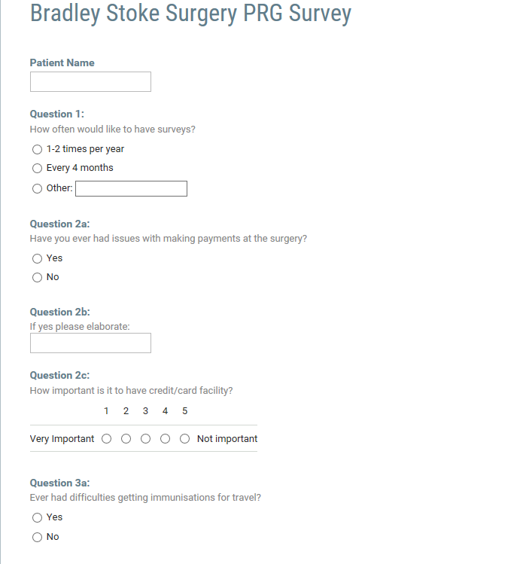
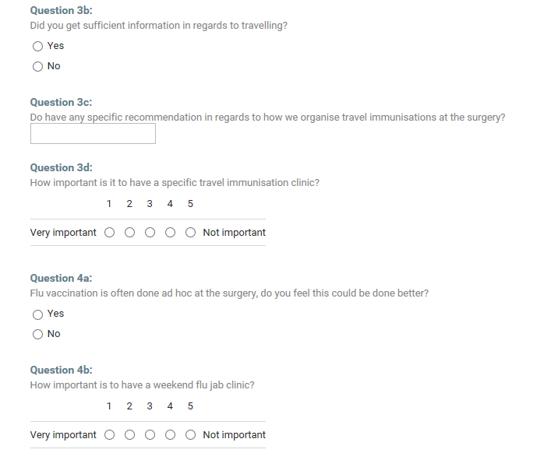
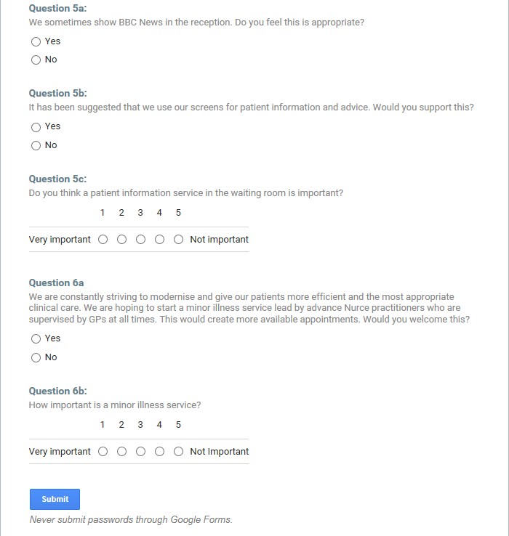

Appendix 2: Survey results
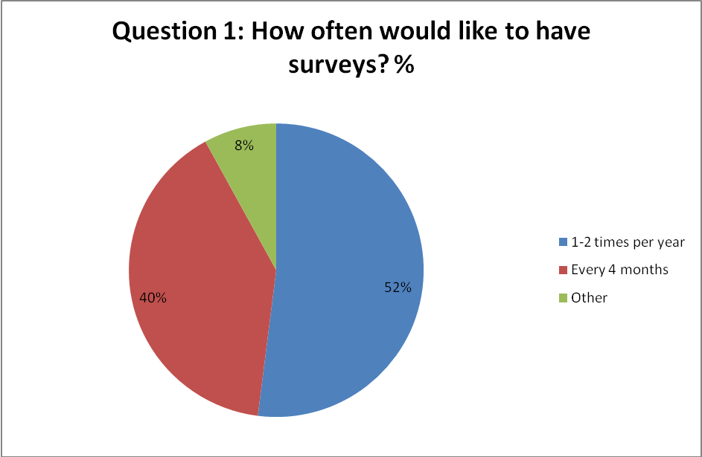
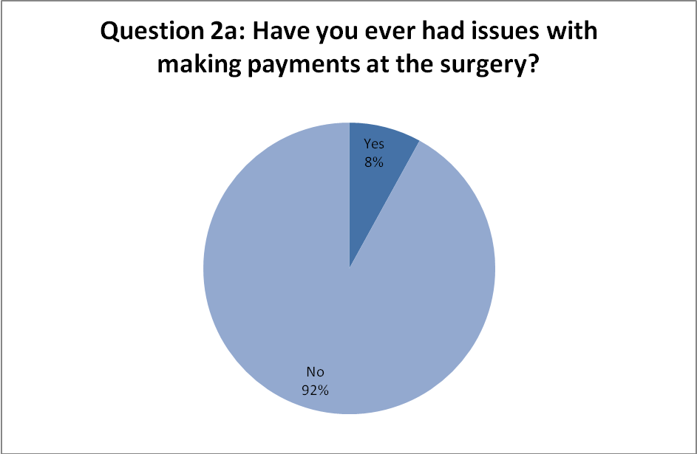
Question 2b: if yes to 2a please elaborate:
No machine to use credit card
No credit card machine

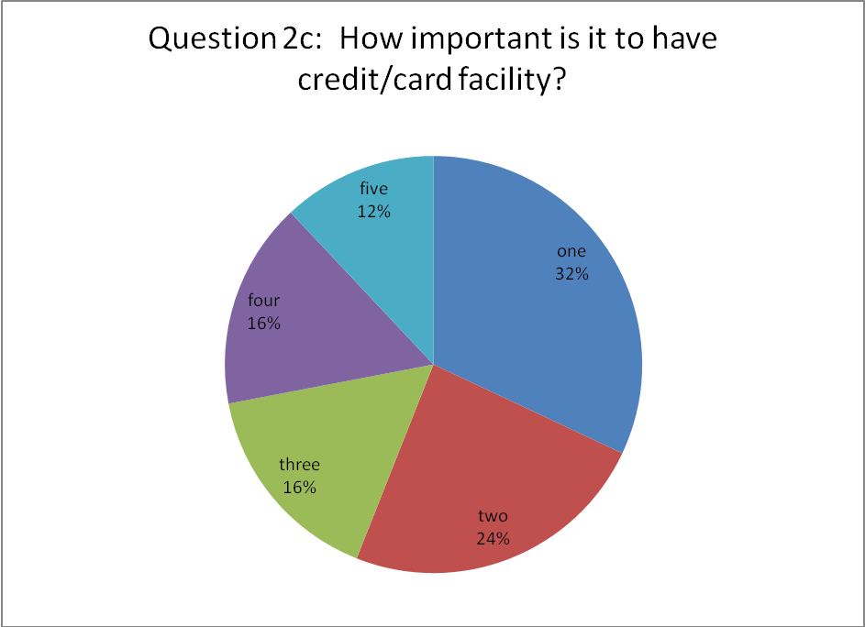

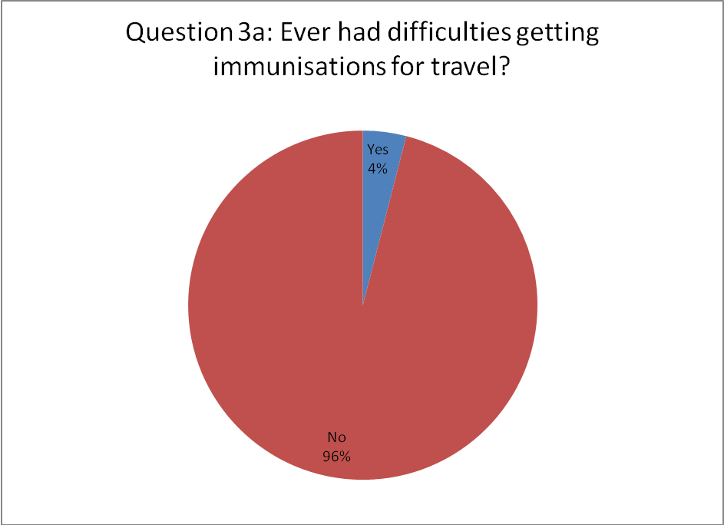
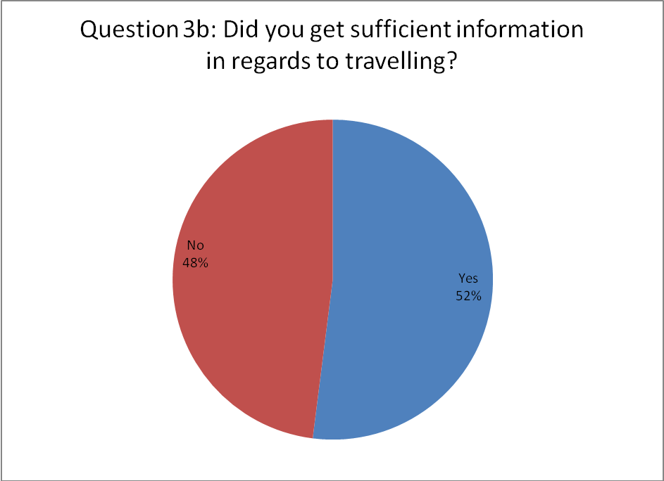

Question 3c: Do have any specific recommendation in regards to how we organise travel immunisations at the surgery?
Friday afternoon clinic with HCA as these appts not often used? Can HCA's be trained to do travel?
Not confident info given
perhaps more information charts in waiting room
None
No

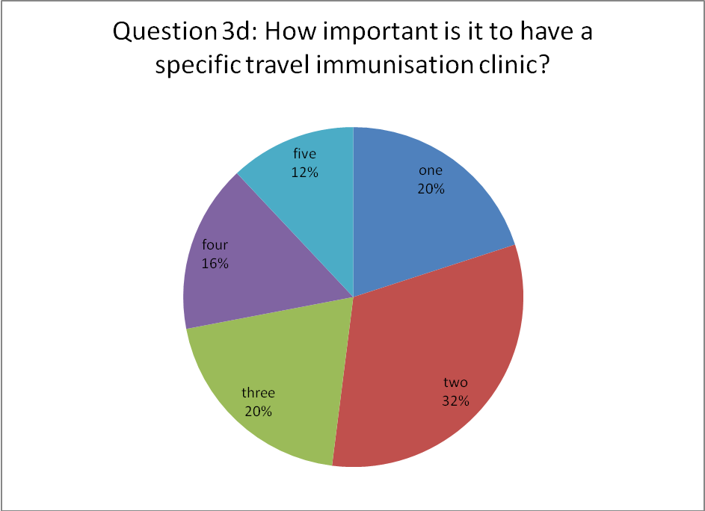
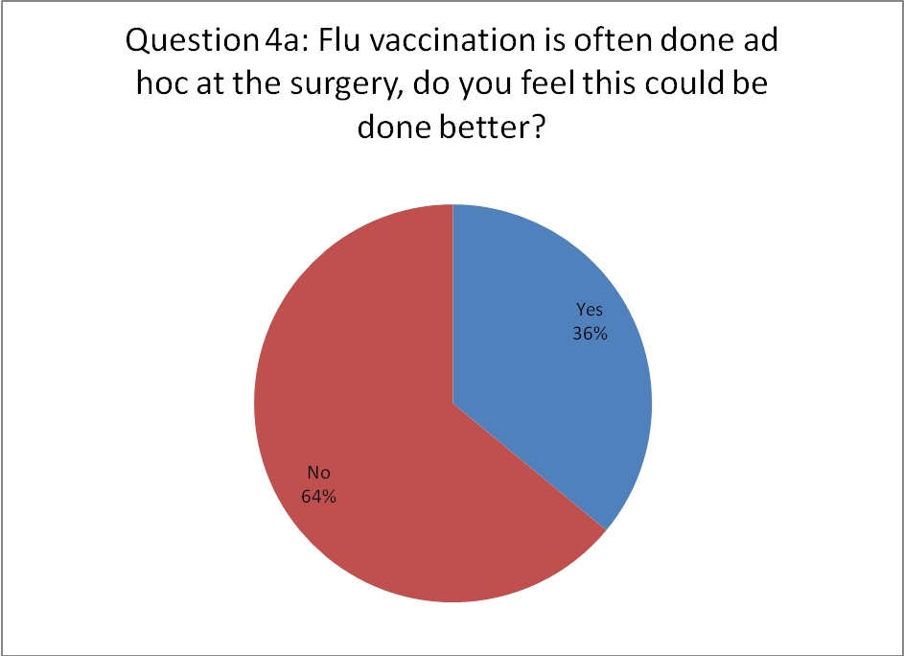
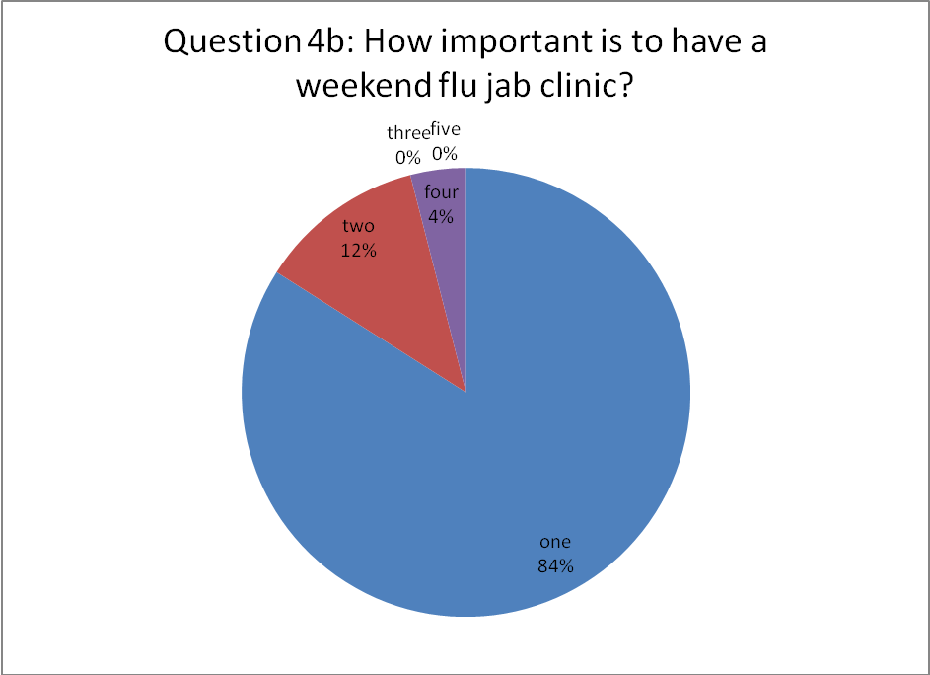
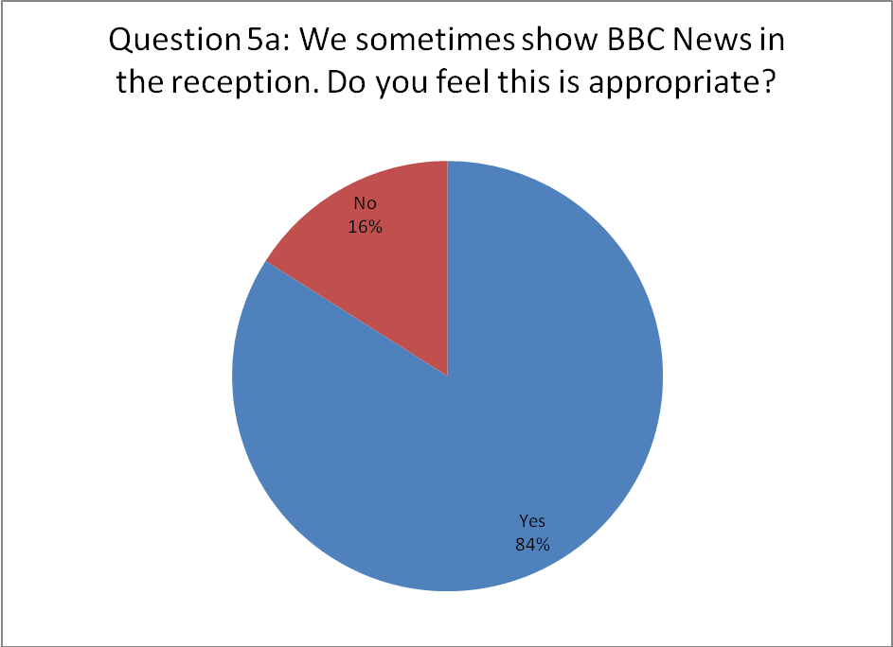
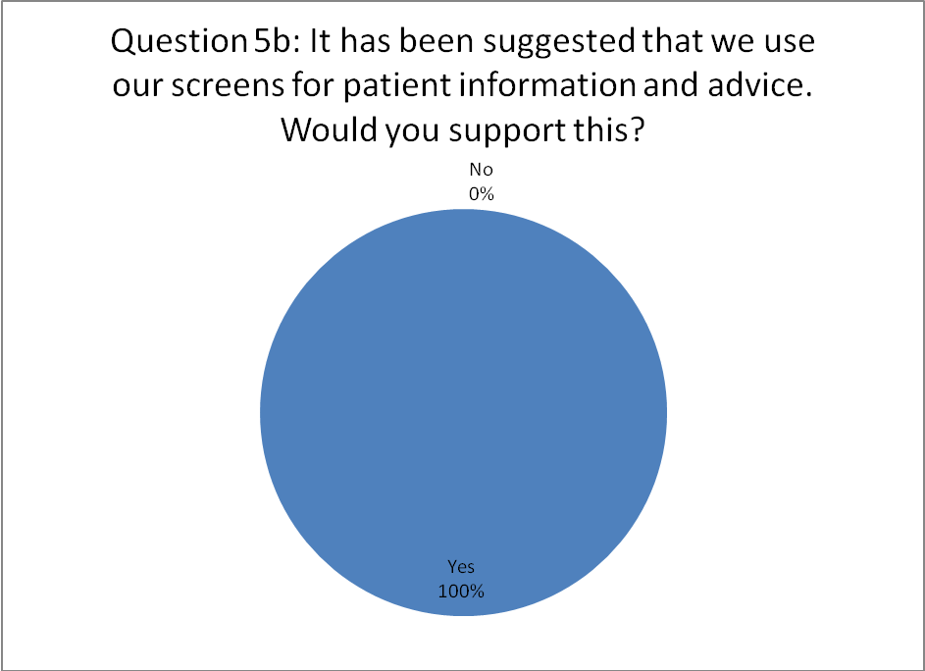
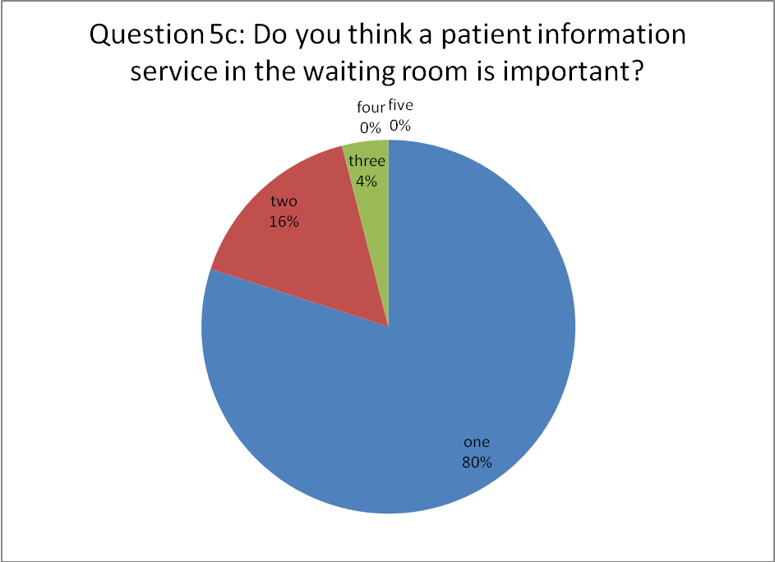
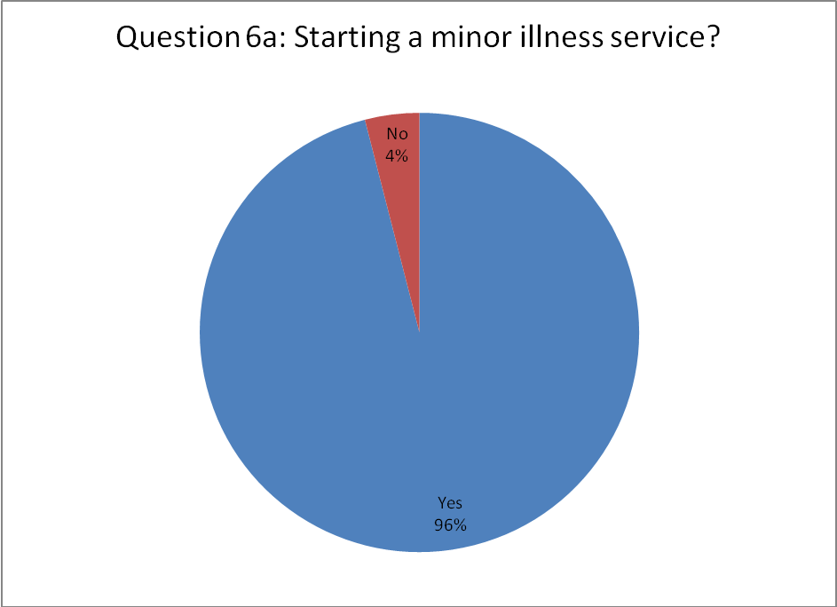
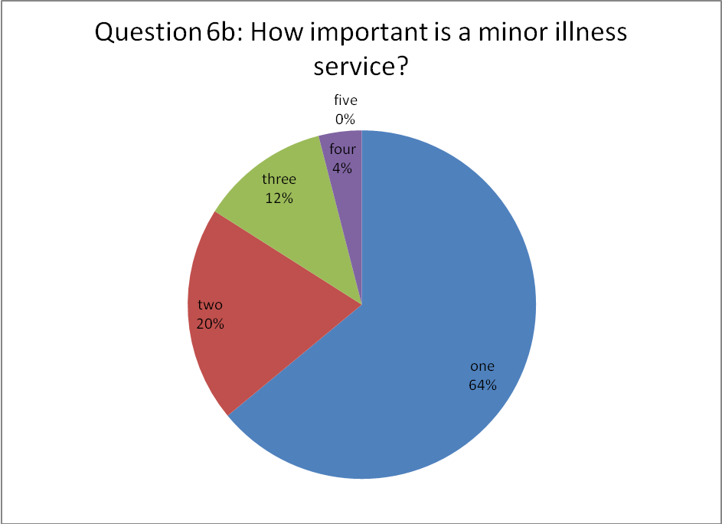

Appendix 3: Sample presentation for reception waiting room

Slide 1
Slide 2
Slide 3
Slide 4
Slide 5
Slide 6
Slide 7
Slide 8
Slide 9
Slide 10
Slide 11
Slide 12
Slide 13
Slide 14

